**FORUM ACTIVITY**

The forum activity facilitates exchanging ideas and comments related to the course topics among the teacher and students or the students themselves. It is an asynchronous discussion space.Forum posts can be rated and the ratings can be aggregated to form a final grade, which is recorded in the gradebook.

**Setting Up of Forum Activity**

1. Select **Turn editing** on from the right top **gear** icon
2. Go to the Unit in which the teacher wants to create the Forum
3. Click the **Add an activity or resources** link there.
4. Select **Forum** activity from the Activity Chooser
5. Provide a meaningful Name and Description for the new Forum
6. Click **Display description on the course page**, if required
7. Decide the type of Forum that the teacher wants to create from among the following five types. Each Forum type behaves a little differently than the others; however, there are commonalities, such as the fact that students can upload files and share them.
8. **A single simple discussion**: In this type of Forum, the teacher posts a question or a topic of conversation, and students are able only to reply to teacher’s question and reply to each others’ remarks. They cannot start a new topic of discussion.**Single simple discussion**is useful if the teacher wishes to keep a discussion focused. Even the teacher cannot start a new discussion.
9. **Each person posts one discussion**: Here, each student posts exactly one new topic, and everyone can reply to it. They cannot initiate a second discussion. When the teacher wishes each student to discuss, say, their reflections or opinion or doubt on a particular topic, and everyone else responds to it, this Forum is useful. Each discussion can then have multiple replies.
10. **Question and Answer forum**(Q and A forum)**:** Instead of initiating a discussion, the teacher poses a question in the initial post of a discussion that she wishes to have answered, and the students respond with possible answers.In order to encourage independent thought,the *Question and Answer forum* require students to post their answers to view other students' postings. Also, others’ posts are visible only after the expiry of the maximum editing time allotted.
11. **Standard Forum for general use:** An open forum where anyone can start a new topic at any time or respond to an existing one.The teacher can use this type of Forum to insist the students to share their viewpoints on the topic they just read.
12. **Standard Forum displayed in a blog-like format**: Similar to the one we discussed above, the only difference is in how the Forum is displayed. With this forum type, one can see the full text of the first post in each Forum. Thus the students can get a glance at everyone’s answers without having to click into each discussion topic.
13. Under **Availability** decide the **Due Date**of the forum posting. It is possible to post even if the teacher enables a due date. To prevent a student from posting after the due date enables a **cut-off date.**
14. Set the size and number of file attachments under [**Attachments and word count**](https://aiishpress.ac.in/moodle/course/modedit.php?add=forum&type=&course=4&section=5&return=0&sr=5)and decide whether the number of words in the post should be displayed with the forum post under **Display Word Count**
15. **Subscription** means the receiving of notification regarding a forum post. The teacher can decide any one of the fivetypes of subscription: **(a) Optional subscription** where it is left to the participants to decide whether to subscribe to a forum or not **(b) Forced subscription**wherein the teacher can make the subscription mandatory for all the students and they cannot unsubscribe later **(c) Auto subscription** wherein every student will be subscribed initially but can unsubscribe later,and **(d) Subscription disabled** wherein the subscription is not allowed for certain students.
16. **Read tracking**, if enabled facilitates highlighting of unread messages by the students.
17. **The discussion can be locked** after elapsing a specified time since the last reply. *This option is not applicable in the case of Single Simple Discussion.*
18. The students can be blocked from posting more than a specified number of posts in a given period under **the Post threshold for blocking.** The students can be warned when they are approaching the maximum number of posts allowed in a given period using the option **Post threshold for warning.**
19. Grades can be assigned to the students for posting discussions, and it can be recorded in Gradebook.
20. [**Ratings**](https://aiishpress.ac.in/moodle/course/modedit.php?sr=5&add=forum&section=5&course=4): The forum posts can be rated. By default, only teachers can rate forum posts, though students can do so if desired.
21. Decide how all the ratings given to posts in a forum are combined to form the final grade (*for each post and the whole forum activity*) under the **Aggregate type:** Average of ratings Count of ratings Maximum rating Minimum rating Sum of ratings.
22. Also, decide the **Grade**and**Grade to pass**
23. Decide the **Aggregate** type of **Rating and the Scale.**

**If the type selected is Scale, then choose Scale for Forum Post from the pop-down menu**

1. **Ratings** can be **r**estricted to the posts within a specific period if required.
2. Maintain the default settings for **Common module**, **Restrict access**, **Activity completion**, **Tags,** and **Competencies.**

**Forum Discussion**

The steps involved in Forum posting/discussion may vary depending upon the type of Forum.

1. **Single simple discussion**

As indicated above,the teacher posts a question or a topic of conversation, and students can only reply and reply to each other. The steps involved are:

1. Follow **steps 1 to 6**described above.
2. Select Forum Type **ASingle simple discussion**from the pop-down menu
3. Follow steps 8 to 20.
4. Click SAVE AND RETURN TO THE COURSE

Accessing the Forum by the Student

1. Now the student will get notification regarding the posts and he can reply to it by accessing the forum post either from his dashboard directly or through the course page.

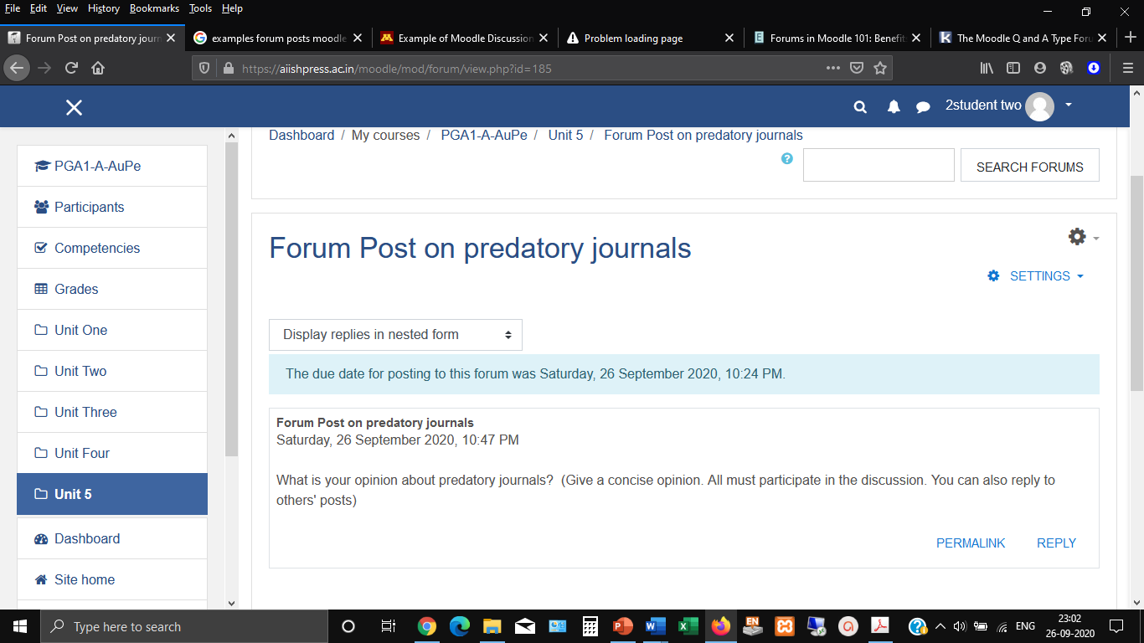

1. The student can see the title of the Forum post and the description on how to post the reply.
2. He can click the REPLY link and type his post in the text box displayed with the heading “Write your reply”
3. The students who are accessing the forum subsequently can see others posts and they can comment to other students posts as well as can answer to the main post of the teacher
4. **Each person posts one discussion:**

Here, each student posts exactly one new topic, and everyone can reply to it. They cannot initiate a second discussion.

1. Follow **steps 1 to 6**described above.
2. Select Forum Type **Each person posts one discussion**from the pop-down menu
3. Follow steps 8 to 20.
4. Click SAVE AND RETURN TO THE COURSE

Accessing the Forum by the Student

1. Now the student will get notification regarding the posts, and he can create a new post by accessing the forum post either from his dashboard directly or through the course page. It will take him to the page to ADD A NEW DISCUSSION TOPIC(Figure)

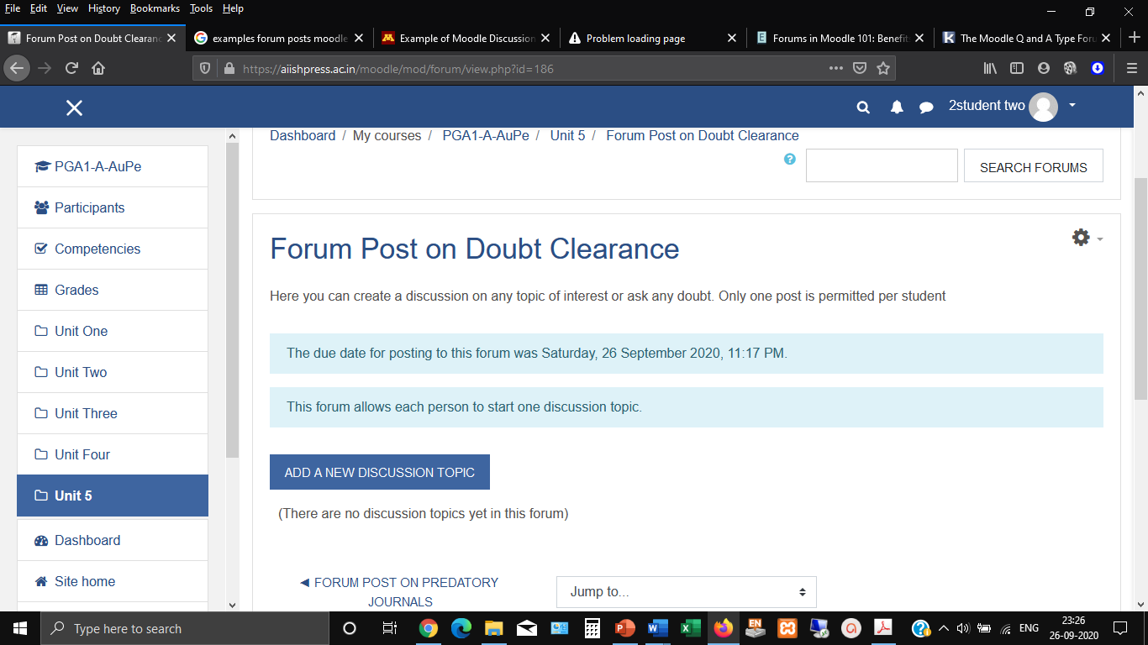

1. Click on it and add the Subject and Message and click POST TO FORUMlink or ADVANCEDto add any files.

**C.Question and Answer Forum**

Instead of initiating a discussion, the teacher poses a question in the initial post of a discussion that she wishes to have answered, and the students respond with possible answers.

1. Follow **steps 1 to 6**described above.*In step 5****description****, mention that this is a question-answer post wherein the student has to answer the question posed by the teacher*
2. Select Forum Type **Question and Answer Forum**from the pop-down menu
3. Follow steps 8 to 20.
4. Click SAVE AND DISPLAY
5. Click ADD A NEW QUESTION button on the resulting page.
6. Add the **subject** of the question and in the message column pose the actual question.
7. Click POST TO FORUM to post or ADVANCED toattach file with the question

Accessing the Forum by the Student

1. The students can see the subject of the post and reply by clicking the hyperlink under the reply button (Figure) and then once again by clicking the **REPLY** link in the resulting page. (Figure )

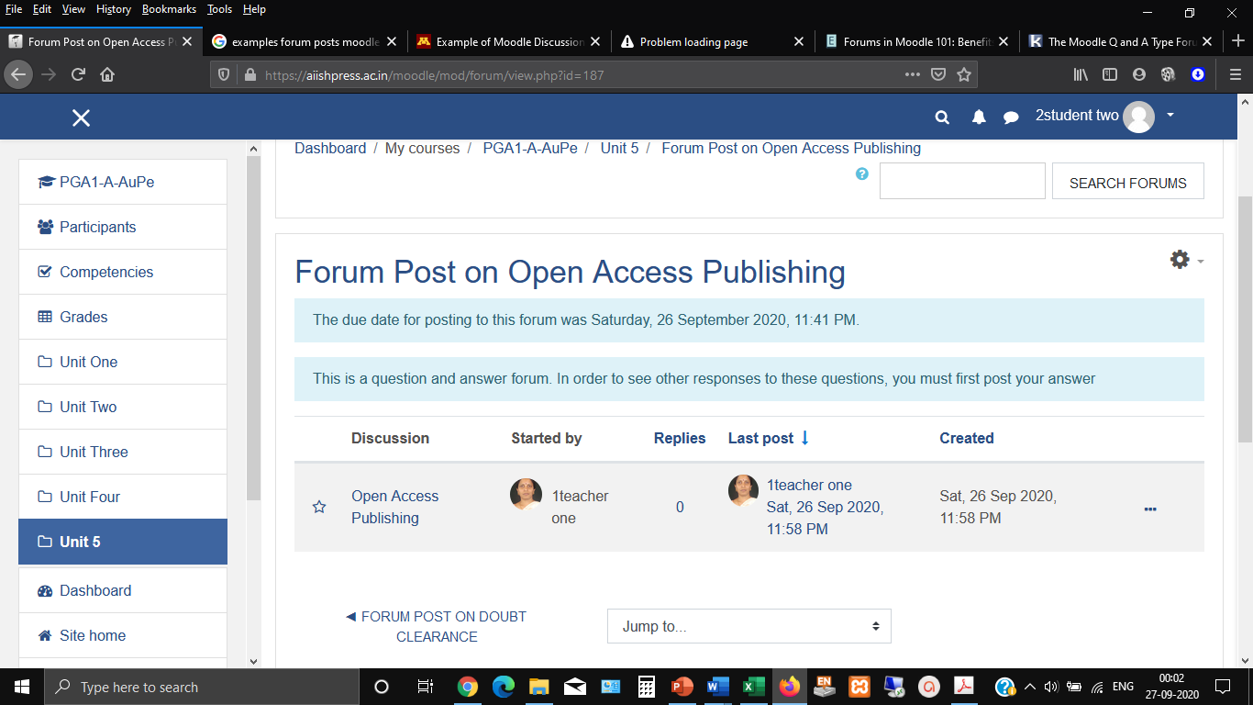

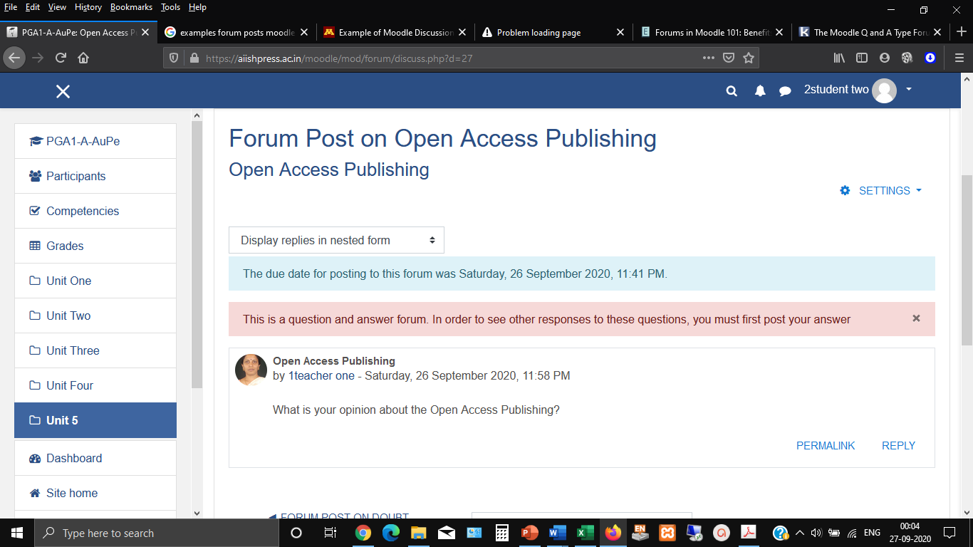

1. **Standard Forum for general use**

An open forum where anyone can start a new topic at any time or respond to an existing one.

1. Follow **steps 1 to 6**described above.*In step 5****description****, mention that this is a* Standard Forum for general use*wherein the student can discuss every topic related to the course.*
2. Select Forum Type **Standard Forum for general use**from the pop-down menu
3. Follow steps 8 to 20.
4. Click SAVE AND DISPLAY
5. Click ADD A NEW DISCUSSION TOPIC button on the resulting page.
6. Add the **subject** of the post and in the message column pose the topic of discussion.
7. Click POST TO FORUM to post or ADVANCED toattach file with the question

**Note**

**1.** A permalink allows a user to link directly to a specific forum post so that it can be shared easily with others. The Permalink option can be seen when clicking to reply to a post. When it is clicked the permalink  is highlighted to the side and with a particular web address which can copy and paste to use elsewhere.

2. In order to easily see the unread posts it can be highlighted by clicking **User Menu 🡪**(*Available at the top right of the dashboard or course home page displayed with the user photo*) and choosing the following options in the subsequent steps **Preference🡪 Forum Preference 🡪Forum tracking**🡪**Yes; highlight new posts for me**